# Lesson 12 Assemble the Smart Robot Car

**Table**

1. What’s in the package 2

2. Precautions for assembly 7

3. Suggestions for purchasing 18650 batteries: 9

4. Assembly 9

5. Circuit diagram： 36

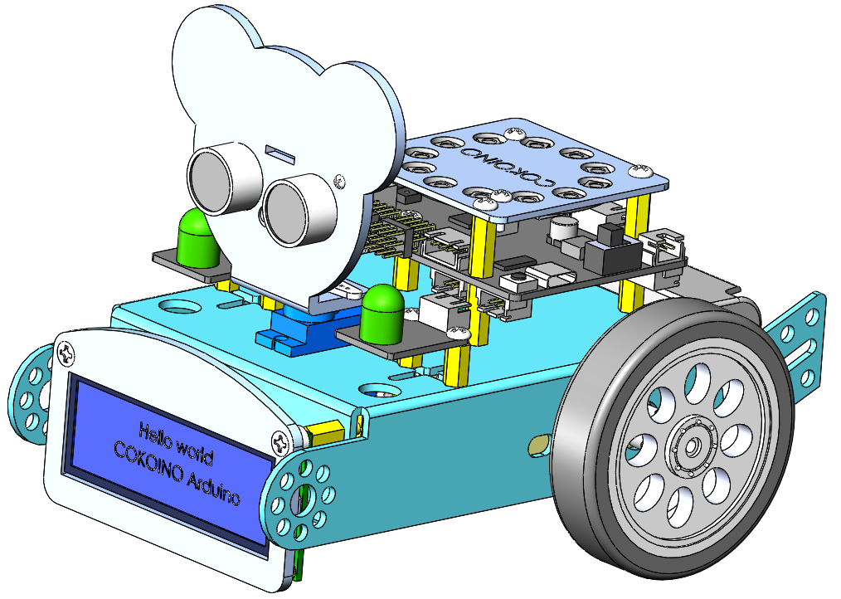

www.cokoino.com

# What’s in the package

## Electronic module

|  |  |  |  |
| --- | --- | --- | --- |
| **Picture** | **Category** | **Name** | **Quantity** |
|  | Controller | LK COKOINO Control Board | 1 |
|  | Module | I2C LCD1602 Display | 1 |
|  | Module | SR-04 Ultrasonic Module | 1 |
|  | Module | Line tracking module | 1 |
|  | Module | ESP-01 Module | 1 |
|  | Module | SW2812 LDE Module | 1 |
|  | Module | 10mm LED | 2 |

## 1.2 parts used to connect or fix

|  |  |  |  |
| --- | --- | --- | --- |
| **Picture** | **Category** | **Name** | **Quantity** |
|  | Screw | P1.2*5 self-tapping screw | 8 |
|  | Screw | M1.6*10 round head screw | 4 |
|  | Screw | M1.6 nut | 4 |
|  | Screw | M2*8 round head screw | 4 |
|  | Screw | M2 nut | 4 |
|  | nylon washer | M3*3mm nylon washer | 4 |
|  | Screw | M3*6MM round head screw | 18 |
|  | Screw | M3*25 round head screw | 6 |
|  | Screw | M3*12 countersunk head screw | 6 |
|  | Screw | Nut M3 | 6 |
|  | copper pillar | M3*10+6 single-pass copper column | 2 |
|  | copper pillar | M3*10 double-pass copper column | 4 |
|  | copper pillar | M3*30MM+6 single-pass copper column | 2 |
|  | copper pillar | M3*15+6 single-pass copper column | 6 |
|  | Battery case | 18650 battery box | 1 |
|  | TT motor | Biaxial reduction ratio 1:48 | 2 |
|  | Servo | SG90 servo | 1 |
|  | Wheel | TT motor wheel | 2 |
|  | Universal wheel | Metal Universal heel | 1 |
|  | Car frame | Aluminum Car frame | 1 |
|  | remote control | Infrared remote control | 1 |
|  | tructural parts | Acrylic structural parts | 1 |

## 1.3 Tool

|  |  |  |  |
| --- | --- | --- | --- |
| **Picture** | **Category** | **Name** | **Quantity** |
|  | wrench | Four-way socket wrench | 1 |
|  | screwdriver | M3 Phillips screwdriver | 1 |
|  | screwdriver | M1.5 Phillips screwdriver | 1 |

## 1.4 Wire

|  |  |  |  |
| --- | --- | --- | --- |
| **Picture** | **Category** | **Name** | **Quantity** |
|  | Wire | 5PIN-150MM for line tracking module | 1 |
|  | Wire | 4PIN-180MM for LCD display | 1 |
|  | Wire | 4PIN-130MM for Ultrasonic module | 1 |
|  | Wire | 3P-70MM for LED module | 2 |
|  | USB Cable | 1M Type-C USB Cable | 1 |

# 2. Precautions for assembly

2.1 Before assembly, turn the power switch on the control board to OFF, and turn the ESP-01 switch to the side away from the "ESP-01" silk screen

2.2 Before assembling the servo to the car frame, please make sure that the servo has been adjusted to 65 degrees.

The code is placed in this folder：

E:\CKK0002-master\Tutorial\sketches\Servo_65_ADJ

Code：

#include<Servo.h>

Servo myservo;  // Create a servo class

void setup() {

myservo.attach(10);  //Set the servo control pin as D10

delay(100);          //delay 100ms

}

/////////////////////////////////////////////////////////

void loop() {

 myservo.write(65);  //The servo is 65 degrees

 delay(1000);

 }

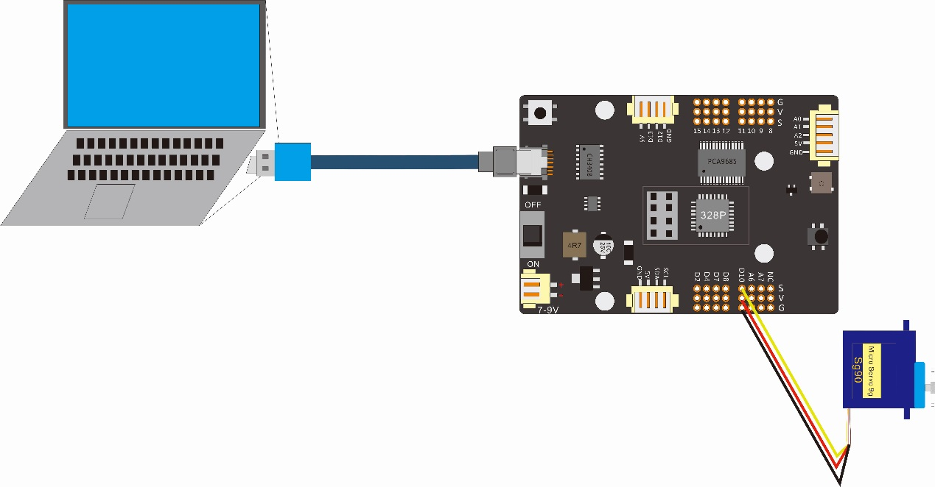

|  |  |
| --- | --- |
| Wiring between the servo and the control board | |
| Connector of the Servo | Connector of the control board |
| + | 5V |
| - | GND |
| Signal | D10 |

2.3 Please use the screw type in strict accordance with the requirements of the assembly document

2.4 The battery case for two 18650 batteries is provided in the Smart Robot car kit, but the 18650 batteries is not provided. You need to prepare two 18650 batteries with enough power by yourself.

# 3. Suggestions for purchasing 18650 batteries:

18mm in diameter, 65mm in length;

Cylindrical battery with a top;

Rechargeable;

Voltage 3.7V, charging termination voltage 4.2V;

Capacity 1500mAh--3000mAh.

# Assembly

## 4.1 Assembly Steps

Note: 1. Before assembling, we need to use a screwdriver to peel off the yellow protective paper of the black acrylic board;

|  |  |  |  |  |  |  |
| --- | --- | --- | --- | --- | --- | --- |
| Step 1 | | | Install 9g Servo | | Tool | M3 Phillips screwdriver |
|  |
| Parts List | Name | Quantity | Unit | Picture | | |
| Car frame | 1 | PCS |  | | |
| 9gServo | 1 | PCS |  | | |
| M2 screw | 1 | PCS |  | | |
| M2*8 round head screw | 1 | PCS |  | | |
| Detailed steps | Description | | | Installation Diagram | | |
| A | 1.Before assembling 9g Servo, you need to adjust it to 65 degree, and the code is stored in this folder:  E:\CKK0002-master\Tutorial\sketches\Servo_65_ADJ  Please refer to lesson 4 to set the servo to 65 degrees.  2.Use M2*8 round head screws and M2 nuts to fix 9g Servo on the car frame;  Pay attention to the installation direction of 9gServo；  3.Pass the Servo cable from the bottom of the frame through the round hole in the frame; | | |  | | |
| Step 2 | | | Install TT motor | | Tool | M3 Phillips screwdriver |
|  |
| Part list | Name | Quantity | Unit | Picture | | |
| step 1 structure | 1 | PCS |  | | |
| TT motor | 2 | PCS |  | | |
| M3 screw | 4 | PCS |  | | |
| M3*25MM screw | 4 | PCS |  | | |
| Detailed steps | Description | | | Installation Diagram | | |
| A | 1. Use M3*25 screws and M3 nuts to install the TT motor on the frame (note the installation direction of the TT motor);  2. Pass the TT motor cable from the bottom of the frame through the round hole in the middle of the frame; (picture omitted) | | |  | | |
| Step 3 | | | Install 18650 case | | Tool | M3 Phillips screwdriver |
|  |
| Part list | Name | Quantity | Unit | Picture | | |
| step 2 structure | 1 | PCS |  | | |
| Battery case | 2 | PCS |  | | |
| M3 screw | 2 | PCS |  | | |
| M3*12 countersunk screw | 2 | PCS |  | | |
| Detailed steps | Description | | | Installation Diagram | | |
| A | 1. Use M3*12MM countersunk screws to fix the 18650 battery box on the car frame (note the installation direction of the 18650 battery box) | | |  | | |

|  |  |  |  |  |  |  |
| --- | --- | --- | --- | --- | --- | --- |
| Step 4 | | | Install Universal wheel | | Tool | M3 Phillips screwdriver |
|  |
| Part list | Name | Quantity | Unit | Picture | | |
| Step 3 structure | 1 | PCS |  | | |
| Universal wheel | 1 | PCS |  | | |
| M3*6 round head screw | 2 | PCS |  | | |
| Detailed steps | Description | | | Installation Diagram | | |
| A | 1. Use M3*6 round head screws to fix the universal wheel on the car frame;  Note the installation direction of the universal wheel; | | |  | | |
| Step 5 | | | Install the 1602 LCD | | Tool | M3 Phillips screwdriver/Four-way socket wrench |
|  |
| Part list | Name | Quantity | Unit | Picture | | |
| step 4 structure | 1 | PCS |  | | |
| LCD display | 1 | PCS |  | | |
| Structure A | 1 | PCS |  | | |
| M3*10MM+6 copper column | 2 | PCS |  | | |
| M3*12MM screw | 2 | PCS |  | | |
|  | M3 nylon washer | 2 | PCS |  | | |
| 4P-180MM wire | 1 | PCS |  | | |
| Detailed steps | Description | | | Installation Diagram | | |
| A | 1. Use the Four-way socket wrench to fix the M3*10MM+6 hexagonal copper column on the frame;  2. Use the 4P-180MM LCD cable to connect to the LCD module;  LCD wiring method:  GND - black wire;  VDO - red line;  SDA - yellow line;  SCL - white line; | | | 3. Use M3*12 countersunk screws to fix the structural part A, M3 nylon washer, and LCD module on the copper pillar on the car frame in sequence;  4. Pass the other end of the cable through the middle hole of the car frame from the bottom of the car frame; | | |
| Step 6 | | | Install the line tracking module | | Tool | M3 Phillips screwdriver/Four-way socket wrench |
|  |
| Part list | Name | Quantity | Unit | Picture | | |
| 150MM 5P wire | 1 | PCS |  | | |
| line tracking module | 1 | PCS |  | | |
| M3*30MM+6 single pass copper column | 2 | PCS |  | | |
| M3*6 round head screw | 2 | PCS |  | | |
| Detailed steps | Description | | | Installation Diagram | | |
| A | 1. Use the four-way socket wrench to fix the M3*30MM+6 single pass copper column to the car frame(note the installation direction of the copper column); 2. Use one end of the 5P-150MM wire to connect the tracking module, and the other end passes through the middle hole in the car frame;   3.Use M3*6 round head screws to install the line tracking module on the copper pillar on the car frame; (note the installation direction of the tracking module) | | |  | | |
| Step 7 | | | Install TT motor | | Tool | # |
| # |
| Part list | Name | Quantity | Unit | Picture | | |
| step 6 structure | 1 | PCS |  | | |
| TT motor | 2 | PCS |  | | |
| Detailed steps | Description | | | Installation Diagram | | |
| A | 1. Install the TT motor wheels on the shaft of the TT motor respectively; | | |  | | |
| Step 8 | | | Install 10MM LED module | | Tool | M3 Phillips screwdriver |
|  |
| Part list | Name | Quantity | Unit | Picture | | |
| Step 7 structure | 1 | PCS |  | | |
| 10MM LED module | 2 | PCS |  | | |
| M3*6 round head screw | 8 | PCS |  | | |
| M3*10 Double-pass copper column | 4 | PCS |  | | |
| Detailed steps | Description | | | Installation Diagram | | |
| A | 1. Use M3*6MM round head screws to fix the M3*10 double-pass copper column to the 10MM LED module (note the installation direction of the copper column); 2. Use M3*6 round head screws to install the Step 7 structure in the grooves on both sides of the car frame; (note that the copper pillars are on the outside when installing) | | |  | | |
| Step 9 | | | Install the control and connect the module | | Too | M3 Phillips screwdriver/Four-way socket wrench |
|  |
| Part list | Name | Quantity | Unit | Picture | | |
| Control board | 1 | PCS |  | | |
| Step 8 structure | 1 | PCS |  | | |
| M3*15MM+6 single pass copper column | 6 | PCS |  | | |
| M3*6 round head screw | 2 | PCS |  | | |
| 3P-70MMwire | 2 | PCS |  | | |
| Detailed steps | Description | | | Installation Diagram | | |
| A | 1.Connect one end of the 3P-70MM wire to the 10MM LED module; (note the wire sequence: GND>black wire; VCC>red wire; IN>yellow wire)  2.Screw 4 M3*15MM+6 single-pass copper posts on the frame;  3.According to the circuit connection diagram provided by us,  connect the left LED module to the X7 Port of the control board,  connect the right LED module to the X6 Port of the control board,  connect the left TT motor to the M1 port of the control board,  connect the right TT motor to the M1 port of the control board,  connect the LCD module to the X3 Port of the control board,  connect the servo to the D10 pin of the control board,  connect the battery box to the power port of the control board,  connect the line tracking module to the X1 Port of the control board; (pay attention to the wiring sequence and corresponding interface)  **Note: The circuit connection diagram is on the last page of this lesson!**  4.Use 2 M3*6MM round head screws and 2 M3*15MM+6 single pass copper column to fix the control board; | | |  | | |

|  |  |  |  |  |  |  |
| --- | --- | --- | --- | --- | --- | --- |
| Step 10 | | | Install 8266 wifi module and LED light ring module | | Tool | M3 Phillips screwdriver |
|  |
| Part list | Name | Quantity | Unit | Picture | | |
| Step 10 structure | 1 | PCS |  | | |
| 8266 wifi module | 1 | PCS |  | | |
| LED light ring module | 1 | PCS |  | | |
| Structure B | 1 | PCS |  | | |
| M2*8MMround head screw | 2 | PCS |  | | |
| M2 nut | 2 | PCS |  | | |
| M3*6 round head screw | 2 | PCS |  | | |
| Detailed steps | Description | | | Installation Diagram | | |
| A | 1. 1. Install the 8266 wifi module to the interface of the control board; (note the installation direction of the 8266 wifi module)； 2. Use M2*8MM screws and M2 nuts to fix the light ring module on the structure B; 3. Use M3*6 round head screw to fix the Step 10 structure to the copper column; (note the direction of the notch in structure B) 4. Connect the cable of the WS2812 light ring module to the X8 connector of the control board;   **NOTE: The wiring diagram is on the last page of this lesson!** | | |  | | |
| Step 11 | | | Install the Ultrasonic Module | | Tool | M3 Phillips screwdriver/Four-way socket wrench |
|  |
| Part list | Name | Quantity | Unit | Picture | | |
| Step 2 structure | 1 | PCS |  | | |
| Structure C | 1 | PCS |  | | |
| Servo cross | 1 | PCS |  | | |
| Servo screw（Packaged with Servo） | 1 | PCS |  | | |
|  | P1.2*5 self-tapping screw | 6 | PCS |  | | |
| M1.6 nut | 2 | PCS |  | | |
| M1.6*8MM round head screw | 2 | PCS |  | | |
| 4P-130MM wire | 1 | PCS |  | | |
|  | Ultrasonic module | 1 | PCS |  | | |
| Detailed steps | Description | | | Installation Diagram | | |
| A | 1. Use P1.2*5 self-tapping screws to install the servo cross on the structure C;（Pay attention to the installation direction of the Servo cross）   2. Install the above structure on the Servo shaft; (note that structure C is parallel to structure A when installing)  3. Use M1.6*8 screws and M1.6 nuts to fix the ultrasonic module on structure C; (note the installation direction of the ultrasonic module)  4.Use 4P-130MM wire to connect the ultrasonic module to the X4 interface of the control board;  **NOTE: The wiring diagram is on the last page of this lesson!** | | |  | | |
| Congratulations, an interesting smart car is finished, and you can start the journey of exploration！ | | | | | | |

# 5. Circuit diagram：

After assembling the Smart Robot car according to the tutorial, do not turn the power switch on the control board to ON immediately. Before that, you need to check whether the circuit connection is correct and whether there is a short circuit, such as checking whether 5V and GND, 3.3V and GND are short-circuited.

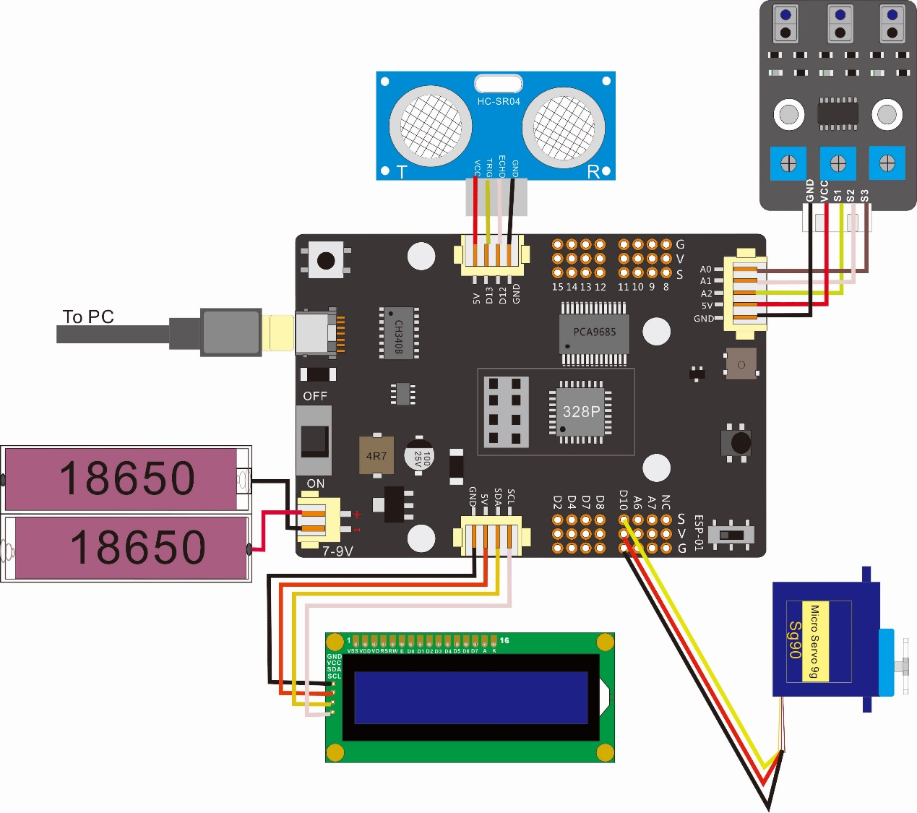

X1

X4

X3

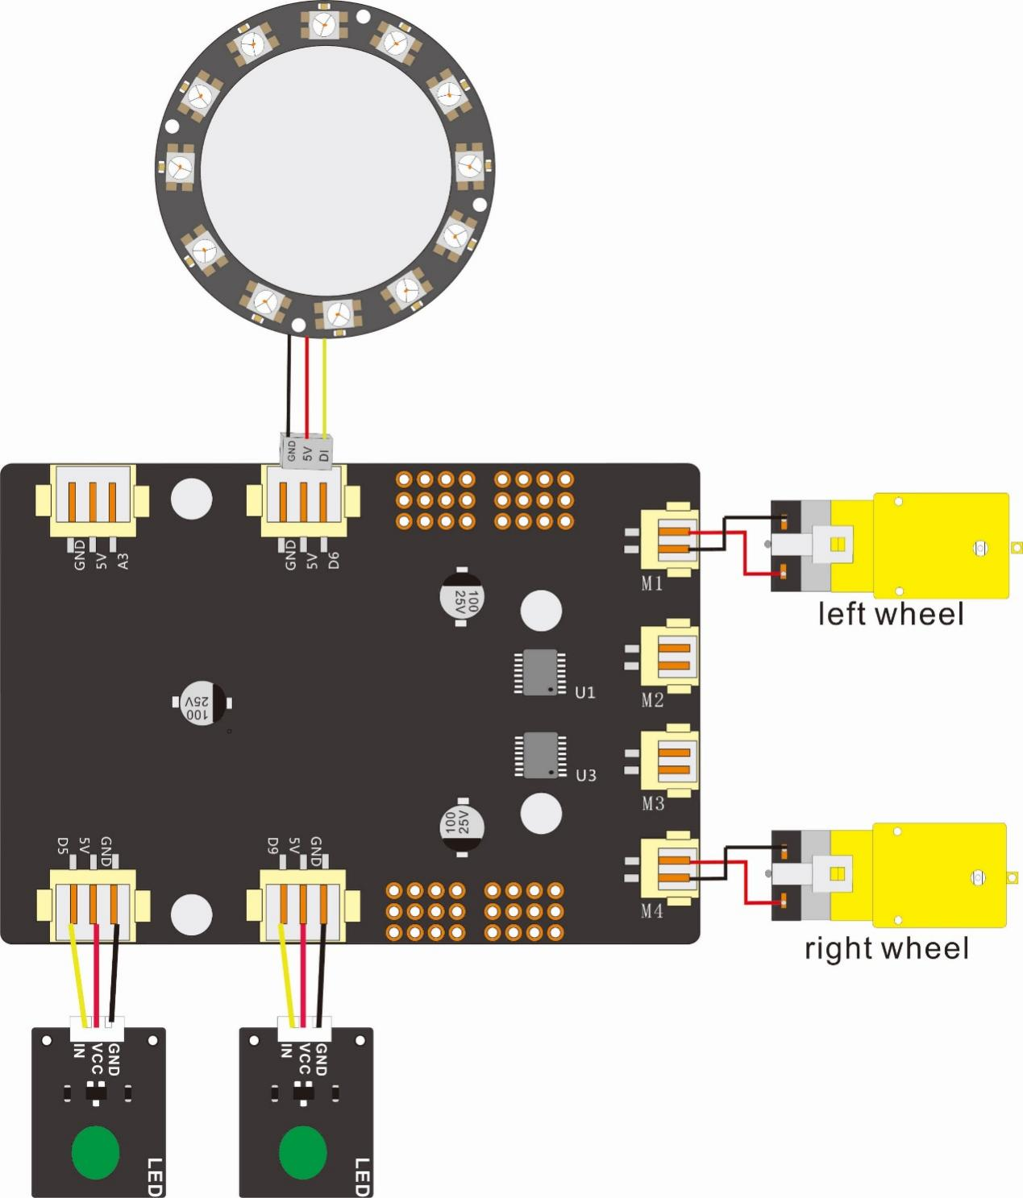

L-LED

R-LED

X8

X7

X6